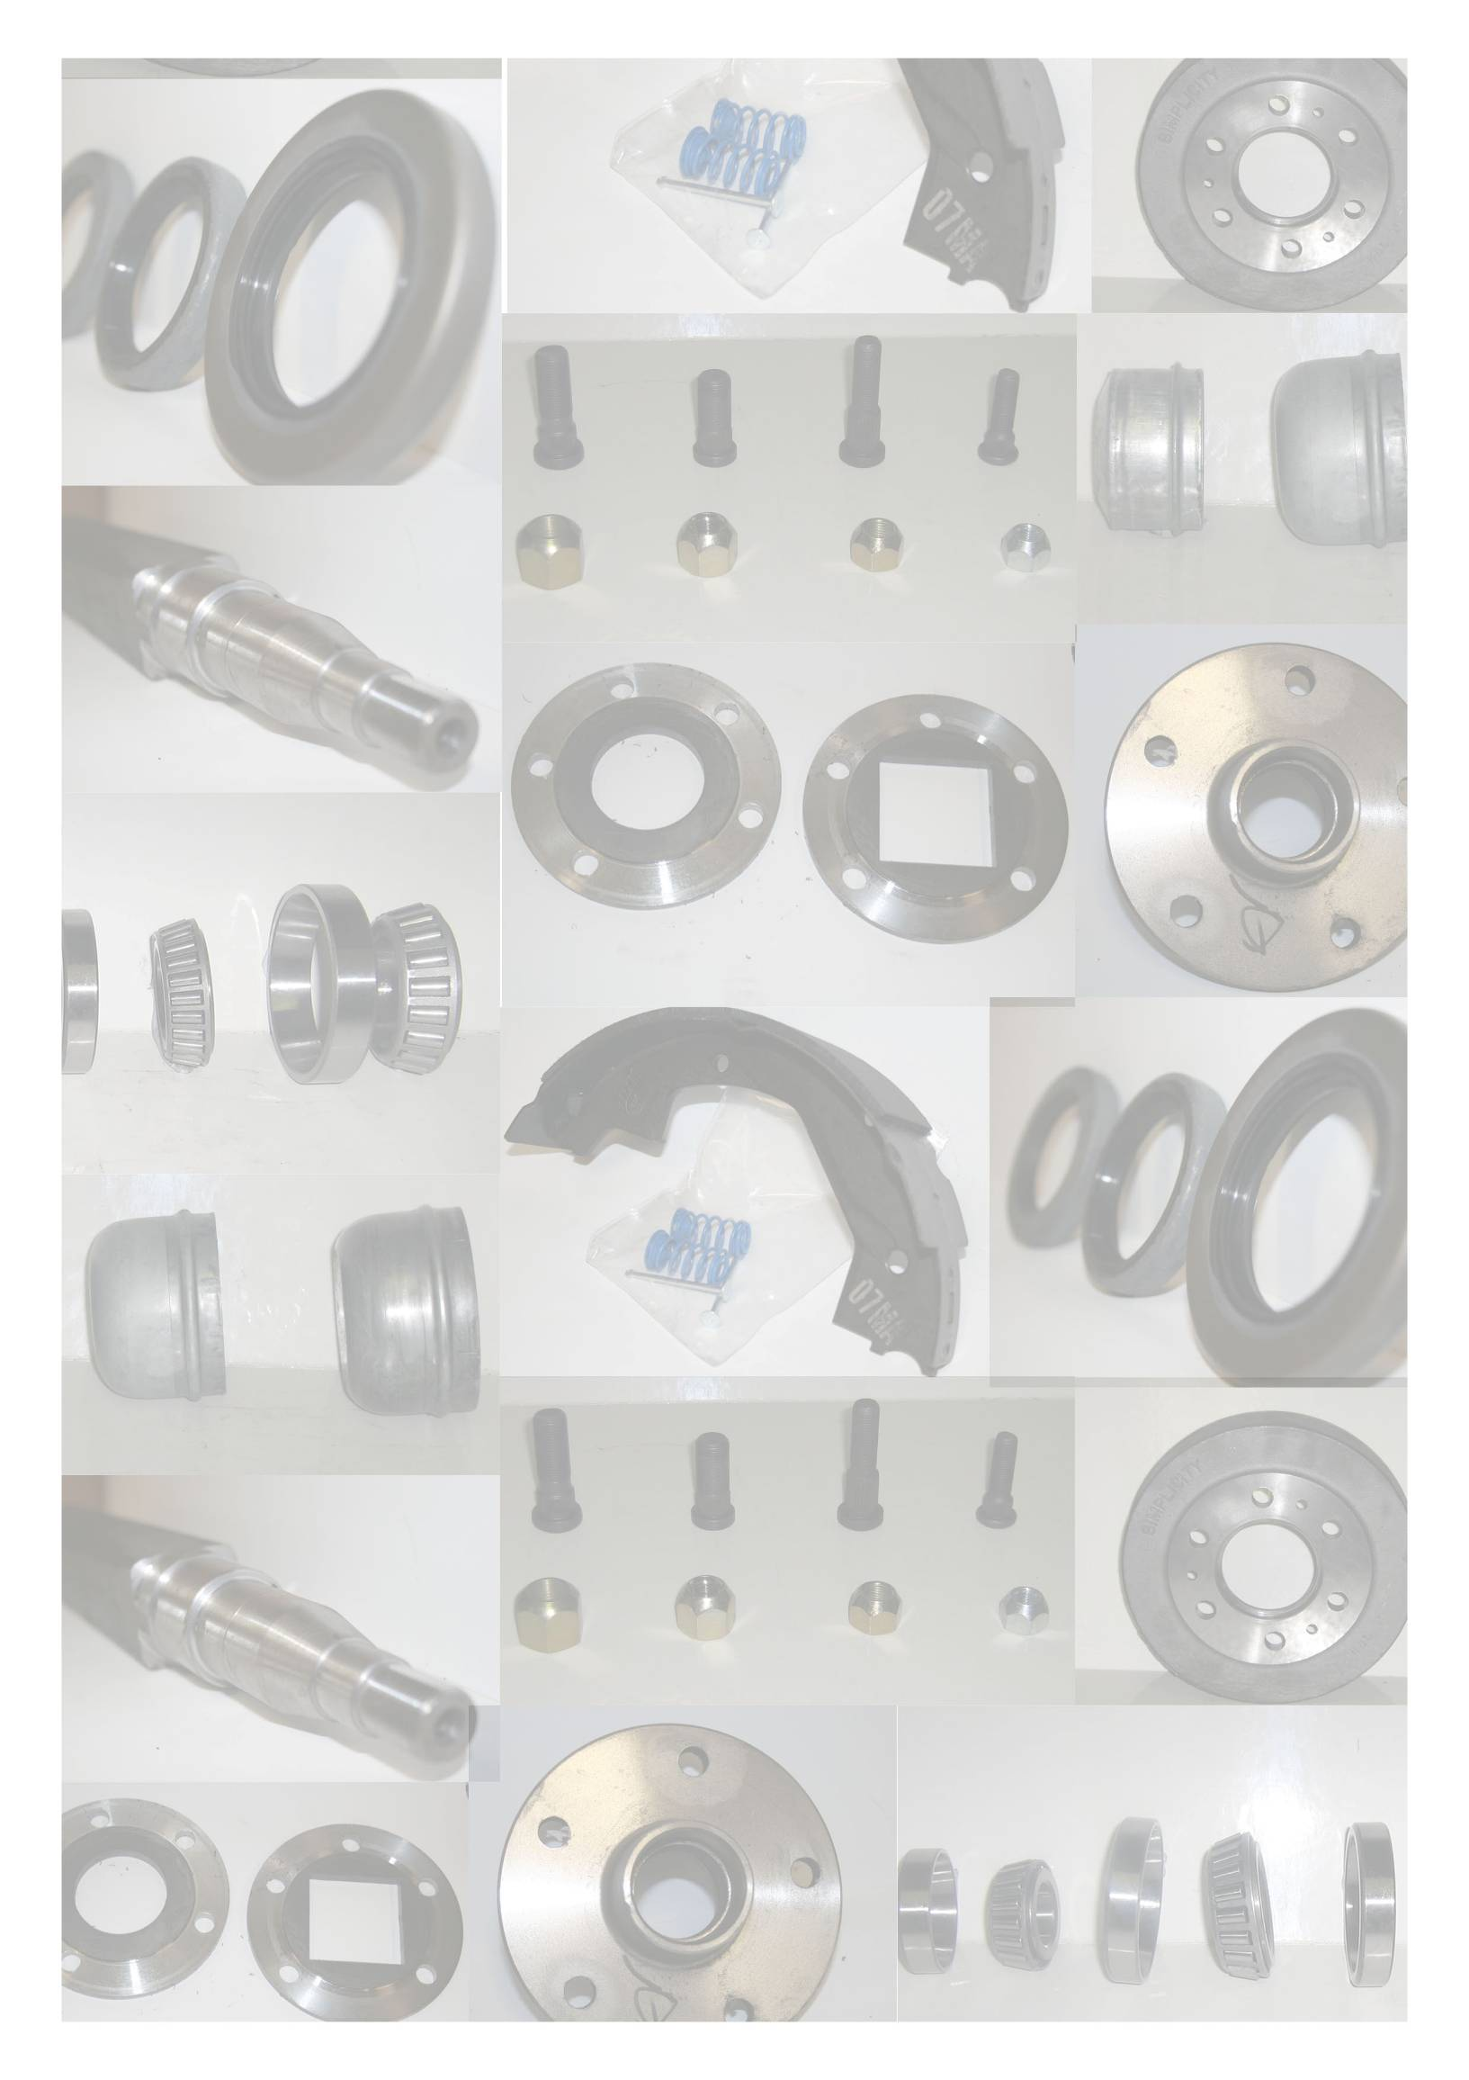
Manufactured and Designed in Australia for Australian Conditions
Proudly Designed & Manufactured by: N.P. HAUFFE & Co. A division of NPNH Nominees P/L A.B.N. 80 285 420 392
2 Childs Road, Epping Victoria 3076. Phone: (03) 9401 4077 Fax: (03) 9401 3077
Email: hauffe@netconnect.com.au Visit us online: www.simplicityaxles.com.au
Simplicity Axles™
Spare Parts Catalogue
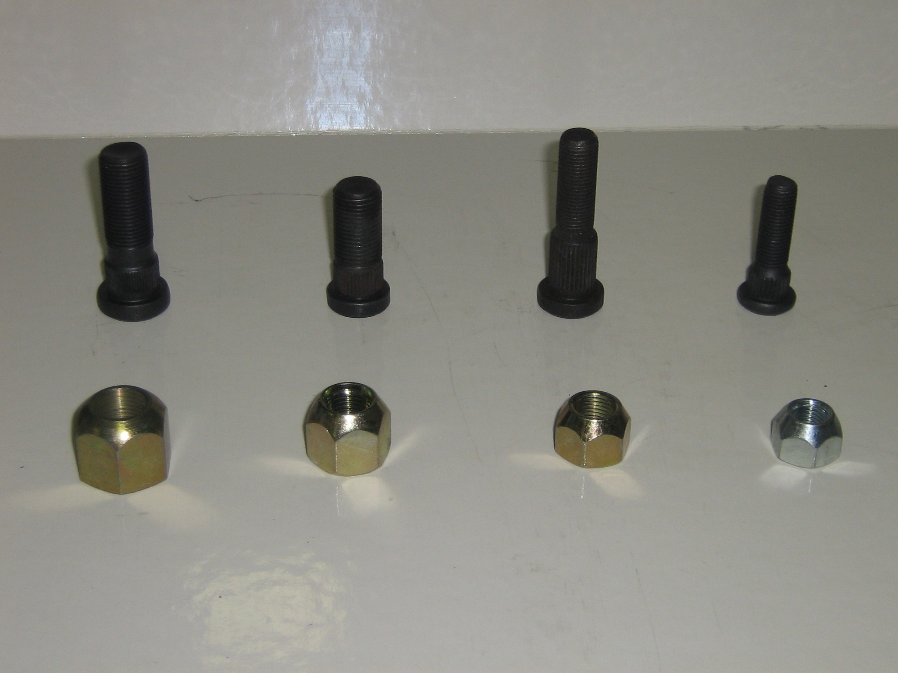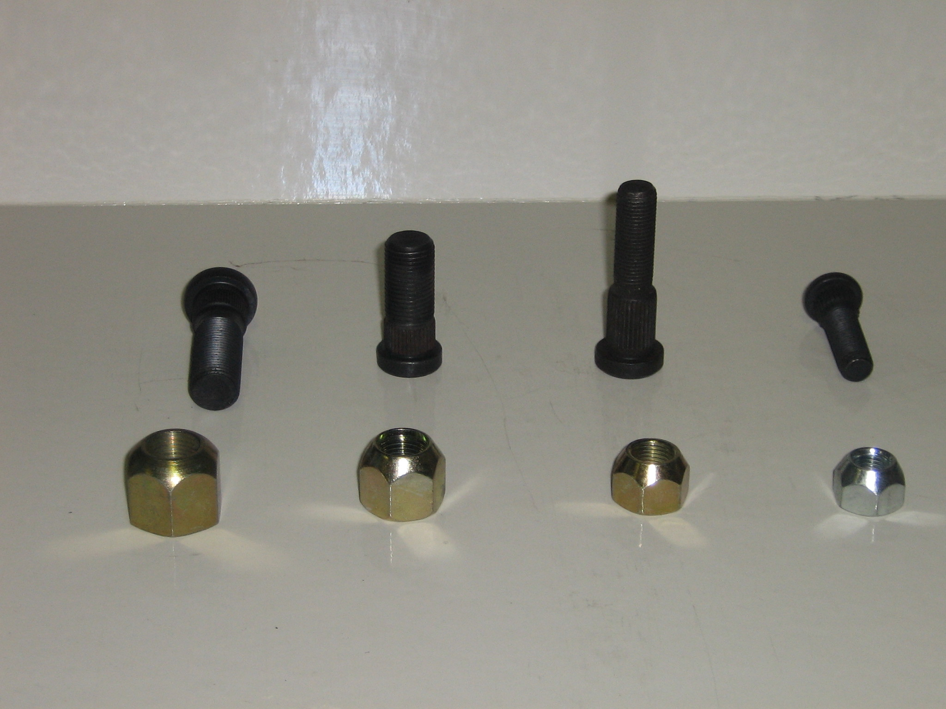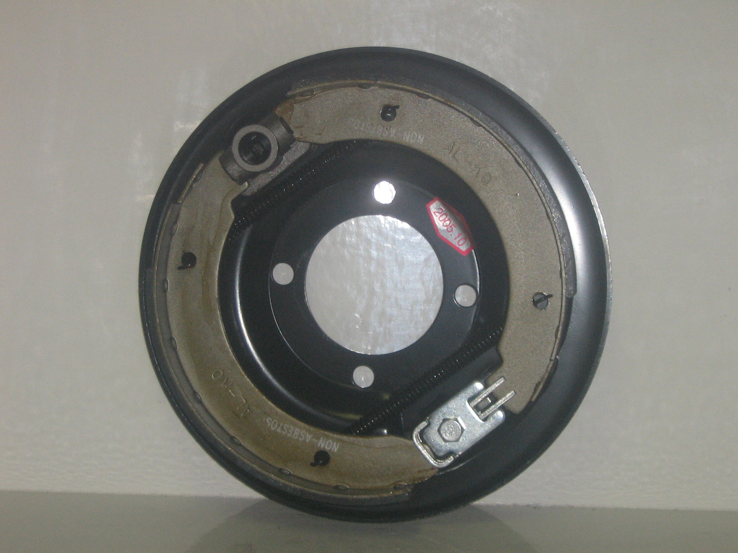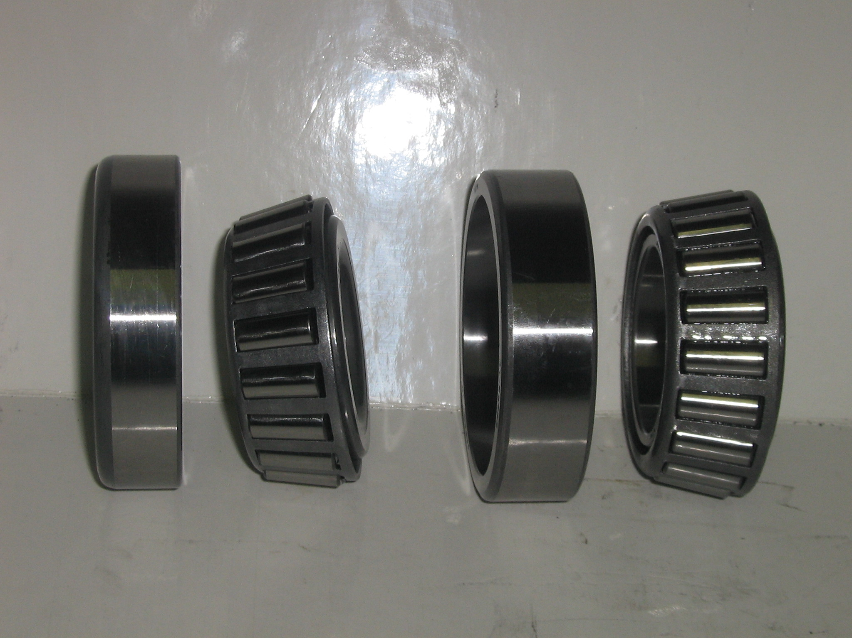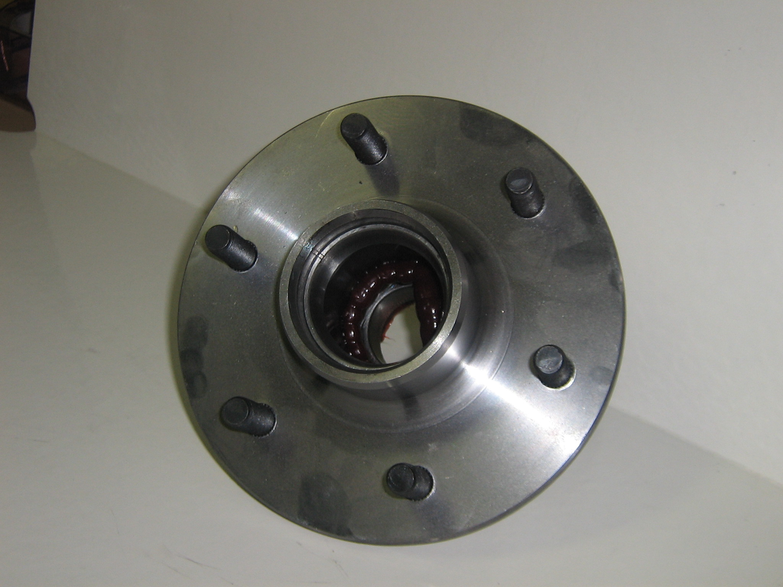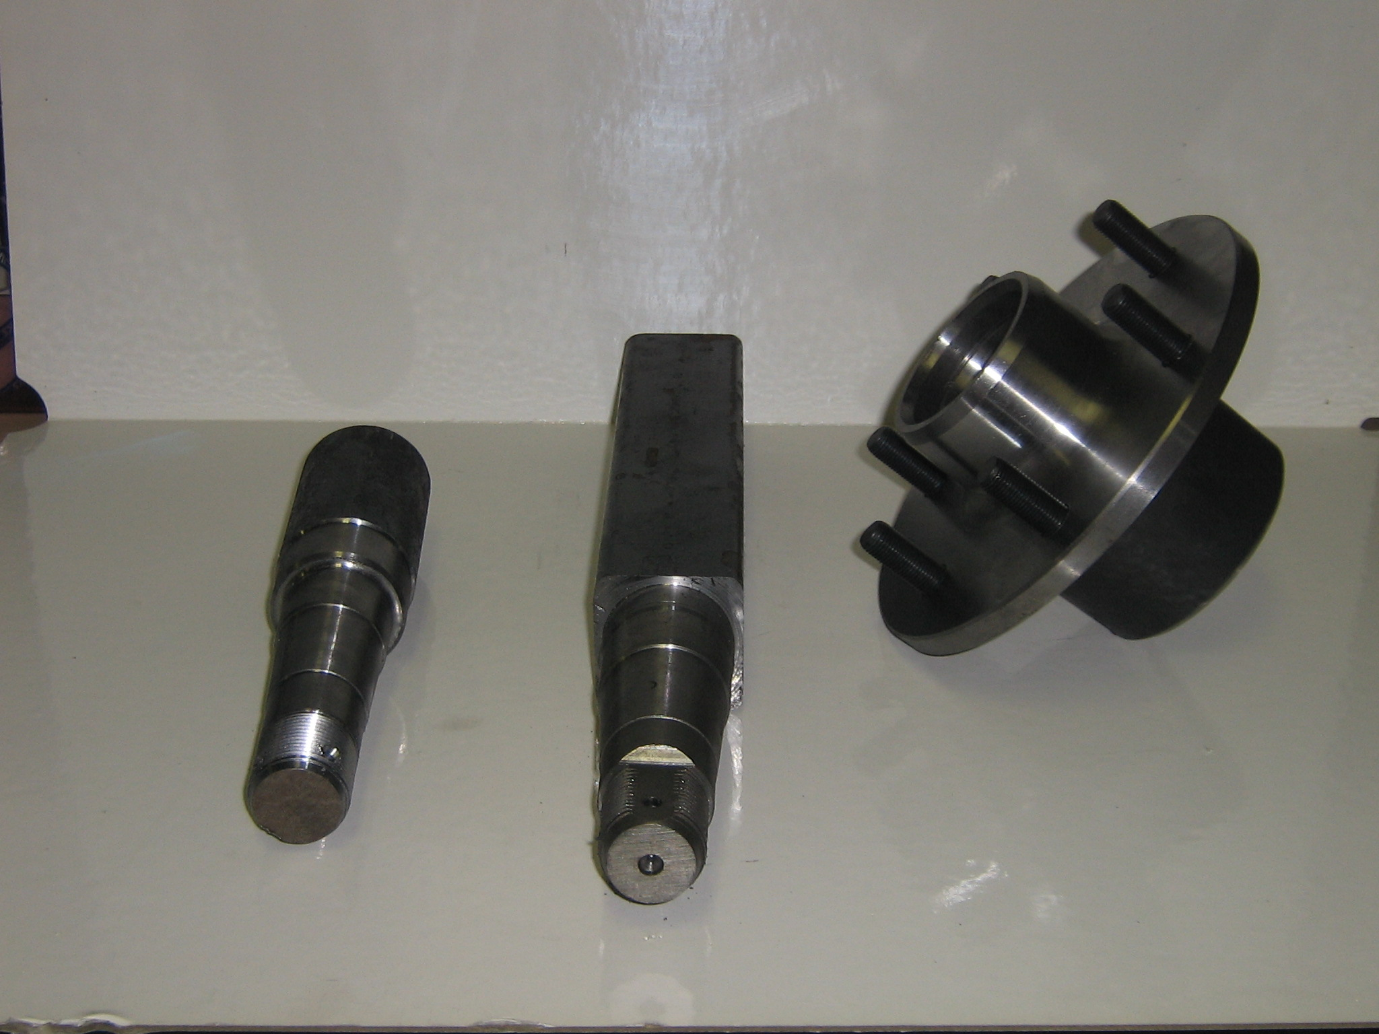

Contents

Serial Number Location on Axle………………………… 4

Wheel Studs & Wheel Nuts ………………………………… 5

Loose Brake Drum 10” x 2¼ ……………………………… 6

Loose Brake Drum 12” x 2¼ ……………………………… 7

Bearings & Seals ………………………………………………… 8

Products Also Available ……………………………………… 9

Dust Caps …………………………………………………………… 10

Electric Brake Mounting Plates ……………………………11

Electric Brakes & Brake Shoes ……………………………12

Electric Brake Magnets & Magnet Arms …………… 13

** Part Numbers for Ordering Purposes

Serial Number Location On Simplicity Tandem Axle System.

When requesting technical assistance or ordering parts for your Simplicity Axle System, quoting your axles’ individual serial number will assist us greatly.

Serial Number format: SXXXX or SXXXXX
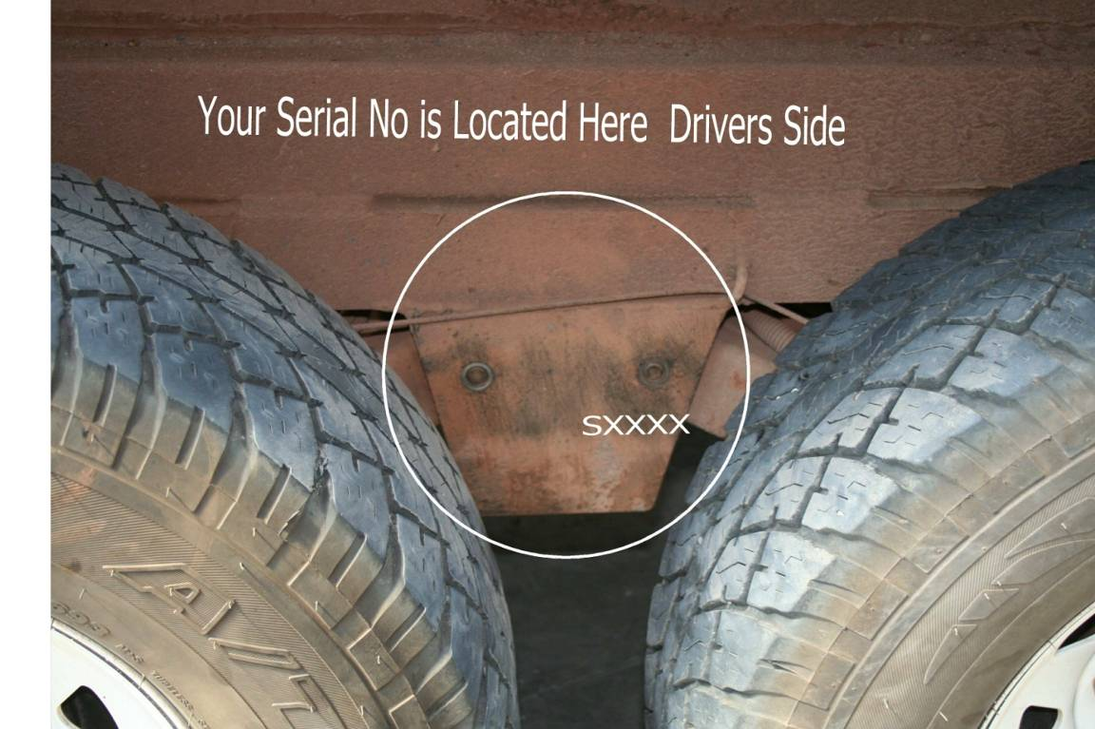

Wheel Studs & Wheel Nuts.

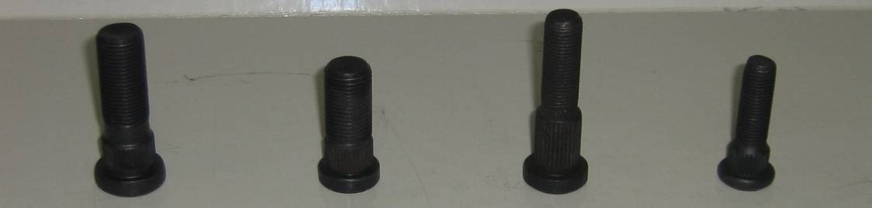

Wheel Studs.
Wheel Studs available in U.N.F. 7/16”, ½”, 9/16” & 5/8”.

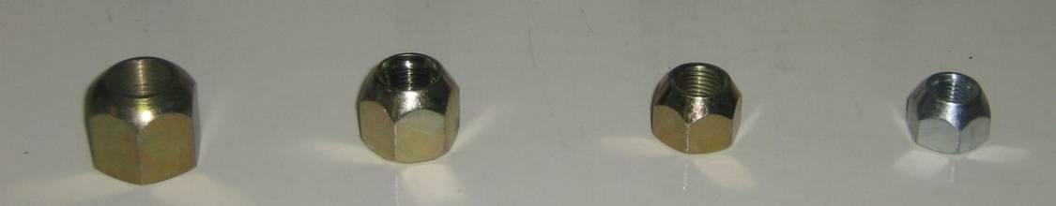

Wheel Nuts. Wheel Nuts available in U.N.F. 7/16”, ½”, 9/16” &5/8”.

Loose Brake Drum.
10”x 2¼
** Ax.HDL10”

Loose Brake Drum 10”x 2¼ to suite A75L Hub

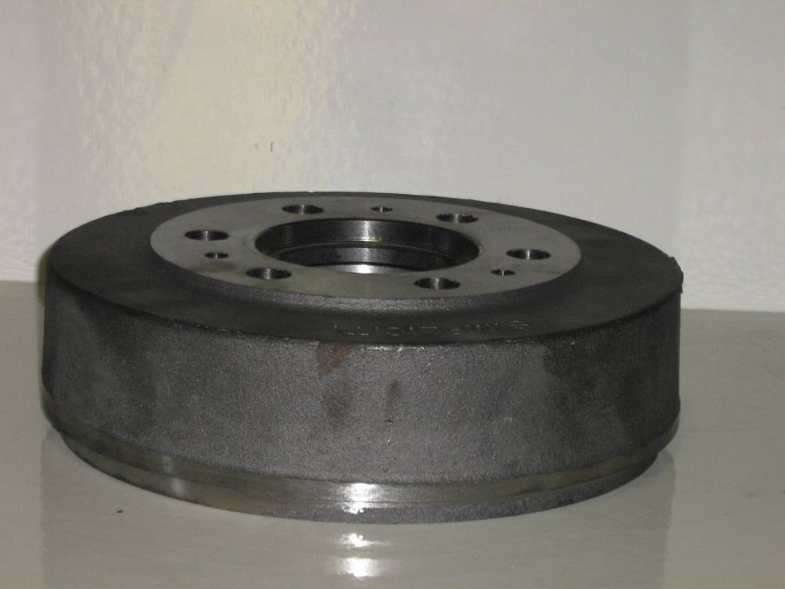

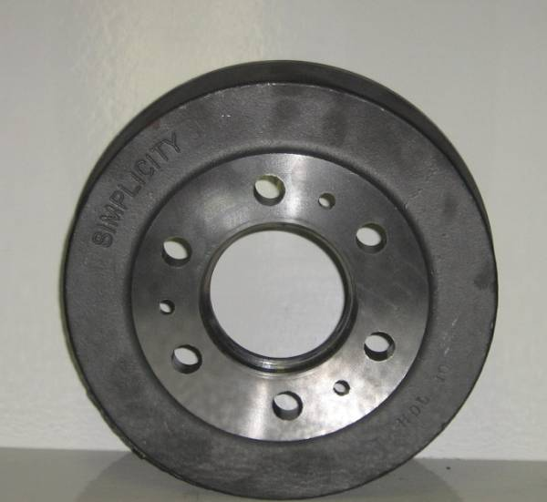

Loose Brake Drum
12” x 2¼
** Ax.HDL12”

Loose Brake Drum 12”x 2¼ to suite A75 Hub.
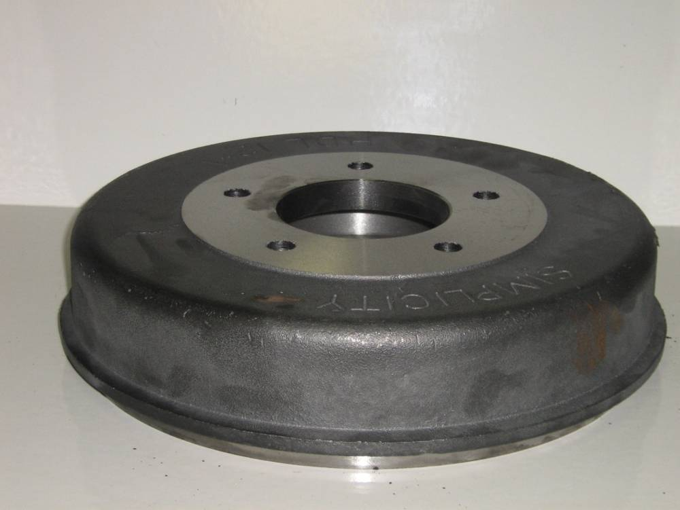

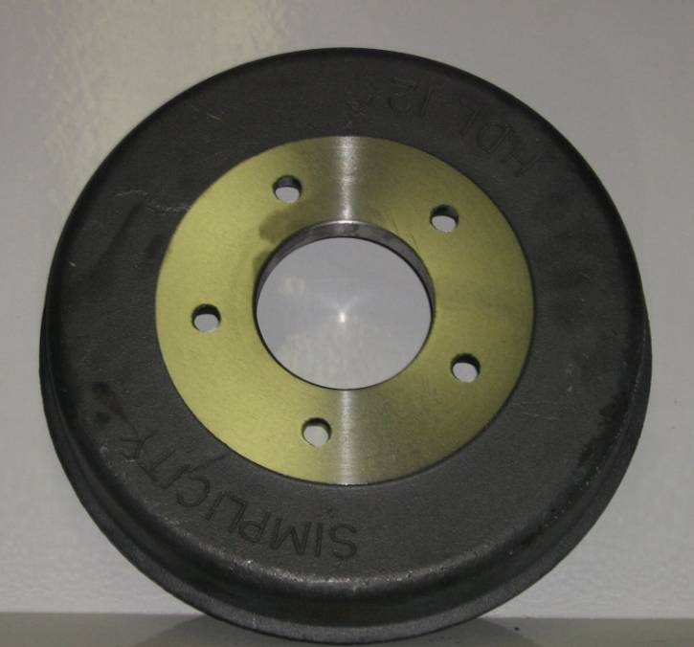

Bearings

Type of hub Cup/Cone Cup/Cone

Large Journal Bearings Small Journal Bearings

Composite LM67010/LM67048 LM12710/12749
** Bear.167010/48 ** Bear. 12710/49
Slimline L68110/L68149 LM12710/12729
** Bear.68110/49 ** Bear. 12710/49
A75L 16284R/16150R LM67010/67048
** Bear.16150/284 **Bear.67010/48
A75 2720/2788 LM67010/LM67048
** Bear.2788/20 ** Bear.67010/48
A75H 26823/26884 L68110/68149
**Bear.26884/23 **Bear.68110/49

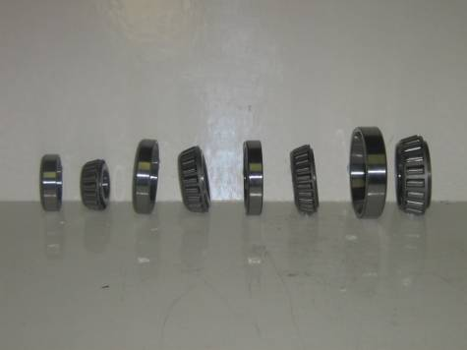

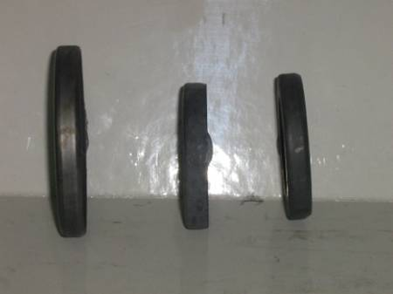

Seals

Type of Seal Part No.

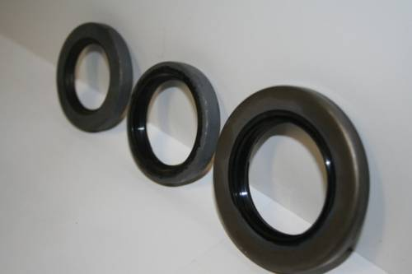Composite HAU 865
** Ax.SealStd.
Slimline HAU 864
** Ax.Seals’line.
A75H HAU 863
** Ax.Seal4.4.
A75 HAU 862 **Ax.Seal.

Products Also Available

A75 Hubs
**A75 L/Chub
(All Steel Hubs)

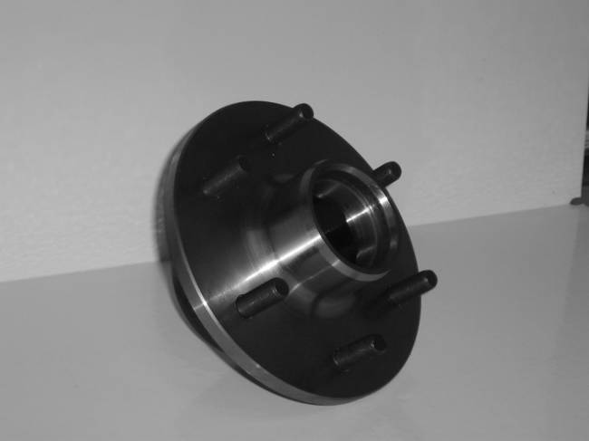Hub drilled to suite all stud patterns 6 Stud, 5 Stud, L/C Ford F250, F100, Chev 8 Stud.
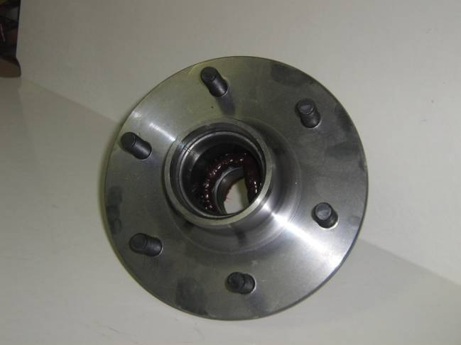
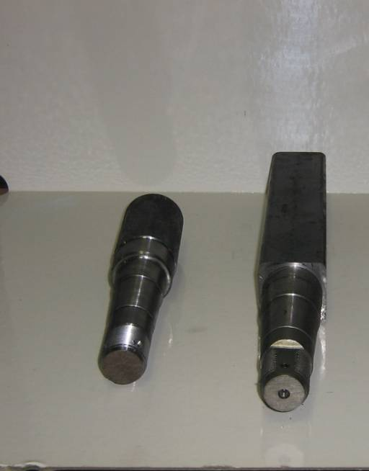

A75 Stubs

50mm round stub 230mm long.
**A75SR
50mm square stub 381mm long.
**A75Stsg

Dust Caps

Standard A74
**Ax.D.Cap1.75 **Ax.D.Cap2 1/16”
1.75mm 2 1/16“
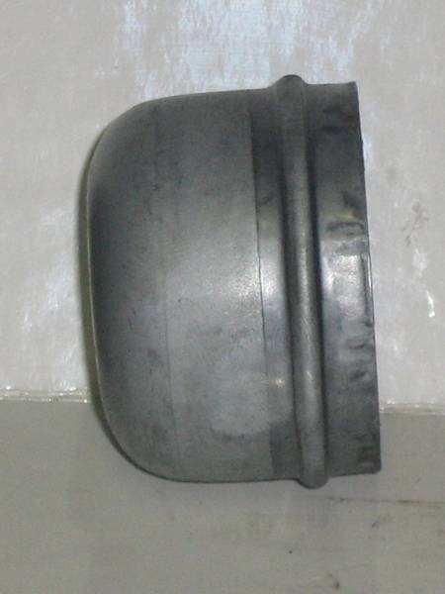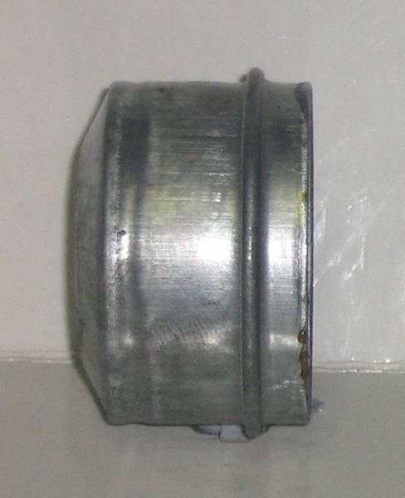

A75 A3
** Ax.D.Cap.59mm. ** Ax.D.Cap.72A3
59mm 72mm
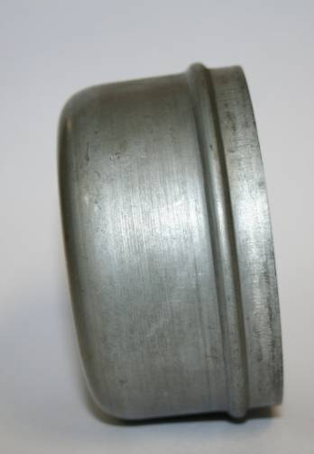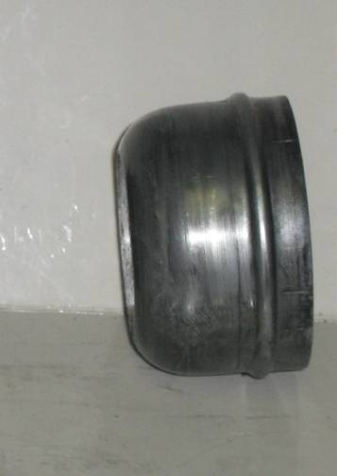

Electric Brake Mountain Plates

10” Electric 10” Electric
45mm Centre 50mm Centre
**10”Ax.EF **10”Ax.EF

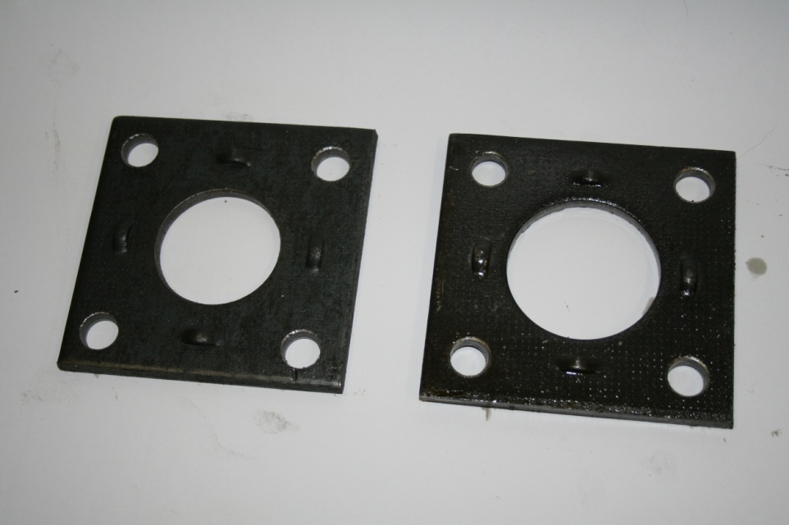

12” Electric 12” Electric
50mm Round Centre 50mm Square Centre
**Ax.EF.12”R **Ax.EF.12”S

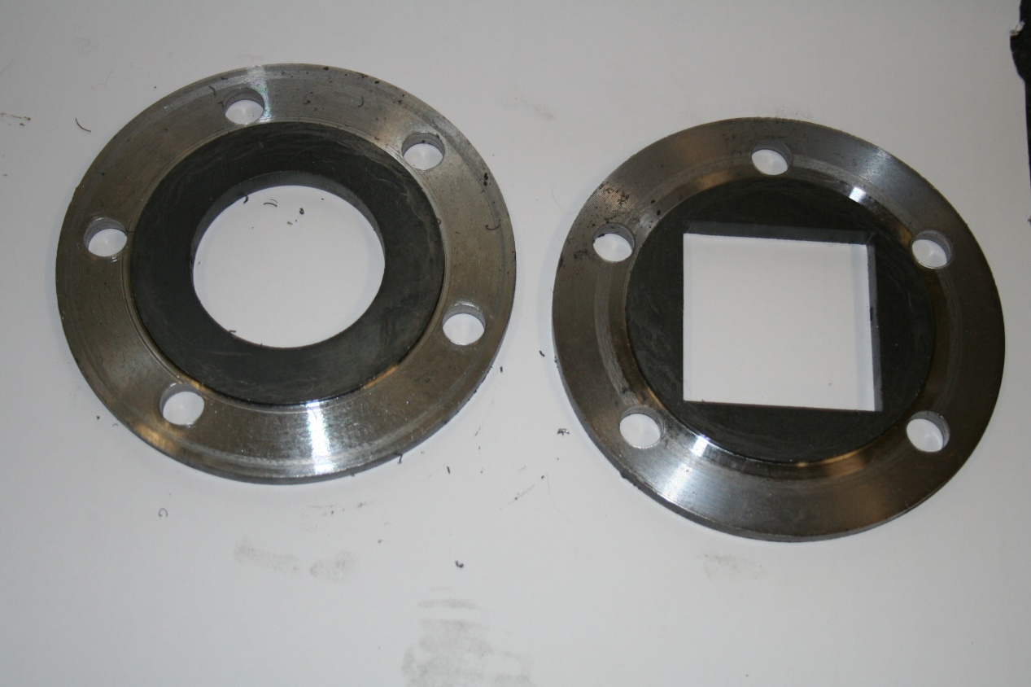

Electric Brakes

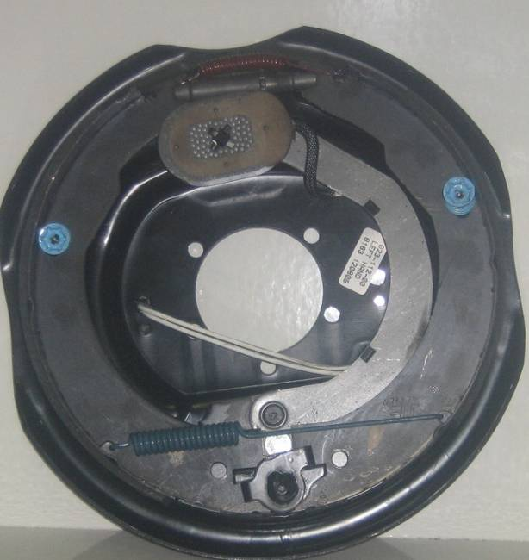

12” electric dexter/alko
**AX.BR.EL.DEX.12” (Dexter)
**AX.BR.EL.AL.12” (Alko)

10” electric alko/dexter
**AX.BR.EL.AL (Alko)
** AX.BR.EL.DEX (Dexter)

Brake Shoes

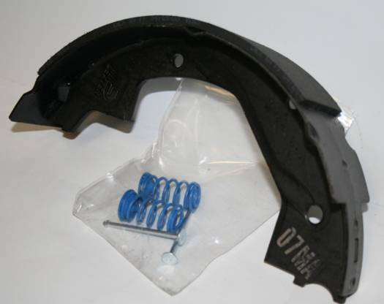

12” Electric Brake Shoes
(12x2” electric brake shoes)
**AX.EL.BR SHOE 12x2

10” Electric Brake Shoes
(10x2¼” electric brake shoes)
**AX.EL.BR SHOE 10”

Electric Brake Magnets

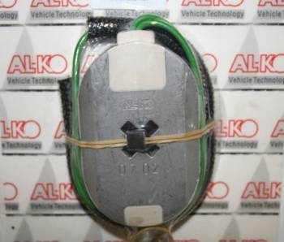
10” Electric Brake Magnet
(10” Hayes oval magnet)
**AX.MAGNET

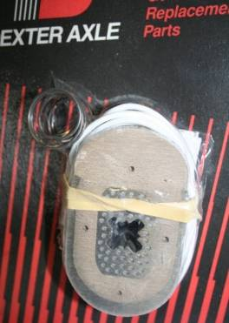
12” Electric Brake Magnet
(12” Dexter oval magnet)
**AX.MAGNET 12

Electric Brake Magnet Arms
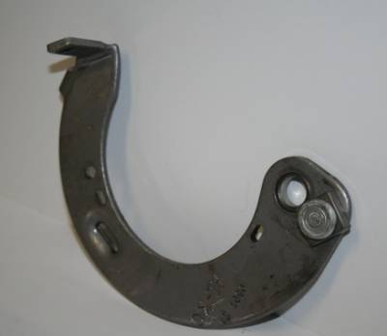
10” Electric Magnet Arm
**

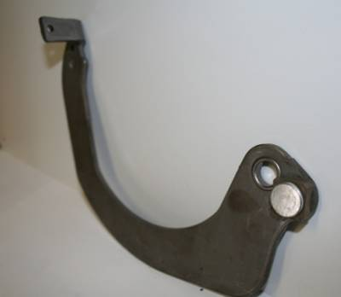
12” Electric Magnet Arm
**

